Steeleye Frontend Engineer Assignment :-

1. Explain what the simple List component does.

The List component accepts an array of objects as props. Each object in this list has a text property. The List component renders the value of the text property of all the elements present in the list prop as an unordered list. By default, each element of the unordered list has a red background which changes to green when the element is clicked. This behavior might be used to tell the user that a particular element is being selected. Only one element can be selected at a time. Only the last clicked element should be green, and the rest of the elements should turn red.  
[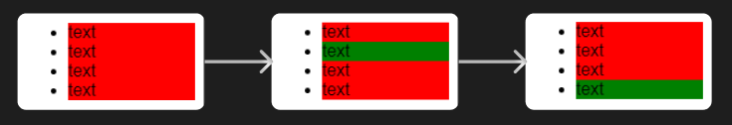](https://user-images.githubusercontent.com/59335572/192138811-5a1c6e80-c6b2-48e3-b337-5114ceac1d76.png)

2: What problems / warnings are there with code?

I noticed the following syntax errors in the code:

* array should be arrayOf as we are defining type of array elements as well. shapeOf should be shape(syntax error).

[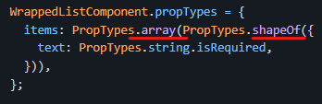](https://user-images.githubusercontent.com/59335572/192139338-fef316e2-489e-47cb-84a5-ddf847cd1b90.png)

* following the convention, the return value of useState should be destructured like this: [selectedIndex, setSelectedIndex] = useState()

[image](https://user-images.githubusercontent.com/59335572/192139521-bf099403-6b60-4ee6-a735-fb4671e01620.png)

* the isSelected prop expects a boolean value. I was able to catch this semantic error through propTypes defined for the SingleListItem component. Here is one possible solution: isSelected={selectedIndex === index}

[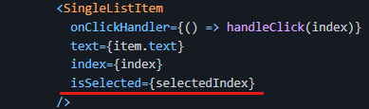](https://user-images.githubusercontent.com/59335572/192139667-a4a2e35d-a9a1-444c-8cb5-d1f3271ee7a2.png)

3: Please fix, optimize, and/or modify the component as much as you think is necessary.

:-s I have made the above-mentioned changes in the following sandbox:

<https://codesandbox.io/s/xenodochial-nightingale-dz2en2?file=/src/App.js>